### Base Load Modeling

For steady-state impact studies, power flow analyses are conducted with constant power loads. This study, however, intends to consider the dynamic load i.e. the daily load profile to more accurately assess how the voltage profile and loading on the feeder would vary during the 24-hour period. Therefore, daily load demand curves are ideally required for each customer on the feeder. A load flow analysis will then be conducted (with 0% EV penetration) for every hour of the day.

Metered load data at 15-minute intervals for the total load and of each of the four feeders at the San Juan substation was provided for the days of January and February of the year 2016. This, however, is not useful for an impact study which requires data at a more granular level. Although household demand data exists for TT as recorded by the utility’s Advanced Metering Infrastructure (AMI), it was not made available at the time of writing. Additionally, the number of customers, their rate class and the mapping to their respective host pole-mounted transformer was not indicated in the GIS data for confidentiality. This presents a great limitation to the study as the actual impact on the grid due to EV charging cannot be assessed. Once acquired, this data would be used as the basis for more detailed load modelling and determination of the typical residential load for customers in the area.

For the purposes of this study, customer load data would be roughly estimated by disaggregating the total feeder load. As mentioned in the previous section, due to the unavailability of key data and the size of the feeder, the load was lumped at the primary of each service transformer. Before disaggregating, a statistical analysis of the total feeder load was performed to assess any periodicity.

The residential base load data for every customer on the feeder was assumed to be the same and hence each customer’s base load was the entire feeder’s load divided by the number of customers on the feeder, n. Let the customers on the feeder be, C = {c1, c2, . . . cn}

The base load data was at a 15-minute resolution and required processing to be used with the NREL data. The above simplification is made in the preliminary analysis but made more accurate in the final work by balancing the load

### ELECTRIC VEHICLE LOAD MODELING

Monte-Carlo simulations and user-agent modelling have been cited in the literature as favourable instruments for assessing grid impacts due to mass EV penetration. Monte Carlo Simulations are used to generate multiple scenarios through random sampling of the probability distribution functions of EV demand parameters. These scenarios are then combined to produce a collective load profile for EVs. The proposed methodology for this report was adapted from Alquthami et al. 2022; it is separated into four (4) layers, the Data Layer, Modelling Layer, Simulation Layer and Analysis Layer as shown in Figure 28.

Figure 28: Flowchart for proposed methodology

The first layer relates to data collection, it is where raw data is collected and used as parameters for the model. The second layer uses the raw data obtained to create probabilistic models/probability density functions (PDFs) for the variables that inform the EV demand model. The third layer is a simulation layer that generates a variety of scenarios obtained from random sampling of the PDFs that make up the EV demand model. The final layer is a power flow analysis that uses the scenarios generated in layer 3 and network data to assess impacts on the grid due to EVs.

#### Data Layer

### To assess the impact on the grid due to EVs, particularly on the distribution level, both EV and household demand data is required. Presently, in Trinidad and Tobago, there is little to no data available for daily travel distance, EV adoption rate, a driver working hours, and charging schedule. Instead, the NREL data was used for analysis in its place.

### The data in (Muratori 2017) was used which followed in the modelling footsteps of (Muratori et al 2012, 2013a) These data includes electricity demand profiles for 200 households randomly selected among the ones available in the 2009 RECS data set (US EIA 2009) for the Midwest region of the United States. The files also include in-home plug-in electric vehicle recharging profiles for 348 vehicles associated with the 200 households assuming both Level 1 (1920 W) and Level 2 (6600 W) residential charging infrastructure. The vehicle recharging profiles have been generated using the modeling proposed by (Muratori et al 2023b), which produces real-world recharging demand profiles, with a resolution of 10 minutes. The data of each household was aggregated to produce data that contained charging events independent of a household or vehicle ID.

### The data contained spurious events such as charging stopping for one sampling period and restarting which shows a gap between two periods of charging in the data. These gaps are smoothed by ignoring it and assuming charging never stops. The cause of these stops may be instrumentation errors, grid transients, or data logging issues after recording. The start times and stop times of charge cycles are obtained by stepping through the data set and detecting whether there is a dip in the value being recorded over one sampling period and if so it is ignored, else it is considered the end of the charging event.

The start times and end times for the level 1 and 2 charging respectively were obtained with the same algorithm described above. The durations were calculated from the above times for levels one and two respectively. Start times were converted to minutes from 12AM. E.g. A start time of 690 corresponds to 11:30 AM and a duration of 110 is 1 hour and 50 minutes. This was done to simplify data processing.

#### Modelling Layer

Data from the data collection layer was analysed and aggregated to create probability density functions for the random variables associated with the EV demand. These variables are charging start times and charging duration.

The duration of each detected charging event was obtained by

The start times and durations can be expressed as two empirical distributions. Let be the empirical distribution of start times and be the empirical distribution of duration times both in the unit, minutes.

They both have empirical probability density functions and . To simplify the analysis, an attempt was made to fit them to common parametric p.d.fs using Maximum Likelihood Estimation(M.L.E) which produces two estimates, and, . The distribution fitting was done using fitter v1.5.1 in Python 3.9. The empirical distributions were fitted against 108 common distributions present in the scipy stats library which was more comprehensive than the ones present in MATLAB, R, XLSTAT and Julia packages. The top 10 distributions fitted for level 1 events are shown in Figures 1 and 2 while those for level 2 are shown in Figures 3 and 4.

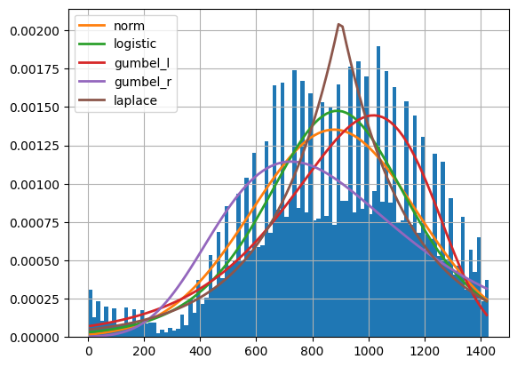

Figure 1. Top 5 distRIBUTIONS FITTED FOR LEVEL 1 START TIMES

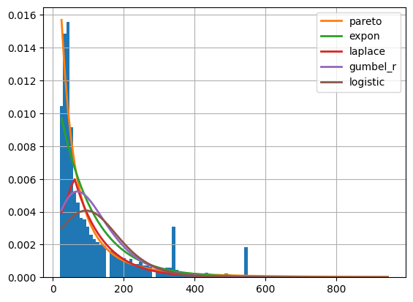

Figure 2. TOP 5 DISTRIBUTIONS FITTED FOR LEVEL 1 durations

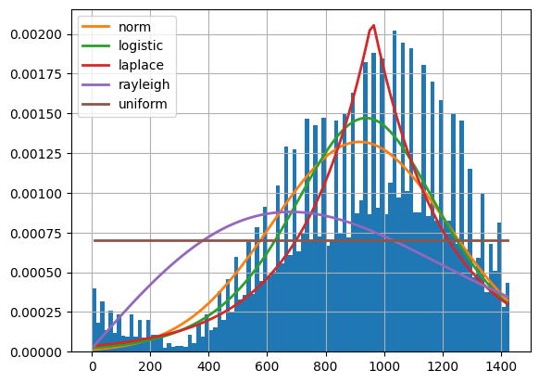

Figure 3. TOP 5 DISTRIBUTIONS FITTED FOR LEVEL 2 START TIMES

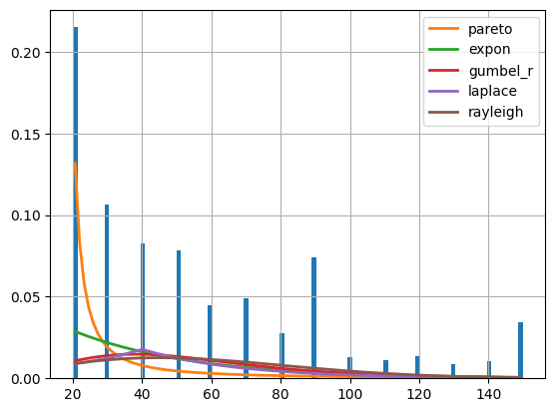

Figure 4. TOP 5 DISTRIBUTIONS FITTED FOR LEVEL 2 DURATIONS

The distributions were compared using sum of squares error, AIC, BIC, and Kullback–Leibler (KL) Divergence. Kolmogorov-Smirnoff (KS) Statistic and KS p-values. The sum of squares error quantifies what the Euclidean distance between the empirical and parametric pdfs are across the domain. The KL Divergence is more powerful and useful in this context than the sum of squares. The information criteria are used to compare the goodness of fit and complexity of candidate distributions against each other by rewarding models performing well in the goodness of fit but penalizing upon the complexity, ultimately favouring simple models with good fits, hence the lowest information criteria is the best choice amongst candidates. The best scoring 5 were plotted using the estimated parameters and shown in the above graphs. The tool produces the fitted distribution’s scale and location parameters which can be used with MATLAB’s *makedist* function to produce a parametric distribution with those parameters. It should be noted that fitting was attempted in MATLAB, however, the fitted distributions were quite poor and resulted in high error metrics.

From Figures 1 and 3, the normal distribution has the lowest KL Divergence value and the lowest AIC, hence it is chosen to model level 1 and 2 start times. Fitting performed quite poorly for durations, however, and the best fit resulting in the lowest AIC and sum square error and catering to at least one mode for both level 1 and 2 was the Pareto distribution.

Table 1. Fitting results of level 1 starting times

|  |  |  |  |  |  |  |
| --- | --- | --- | --- | --- | --- | --- |
| Distribution Name | Sum Square Error | AIC | BIC | KL Divergence | KS Statistic | KS p-value |
| *Normal* | 0.000010 | 1551.4036 | -5.122e+06 | 0.098184 | 0.042678 | 0.0 |
| *Logistic* | 0.000011 | 1553.3176 | -5.103e+06 | 0.099697 | 0.040996 | 0.0 |
| *Gumbel L* | 0.000011 | 1529.0358 | -5.102e+06 | 0.103044 | 0.051486 | 0.0 |
| *Gumbel R* | 0.000015 | 1575.4499 | -5.045e+06 | 0.155591 | 0.106341 | 0.0 |
| *Laplace* | 0.000017 | 1557.2216 | -5.016e+06 | 0.135359 | 0.072367 | 0.0 |

Table 2. Fitting results of level 1 charging periods

|  |  |  |  |  |  |  |
| --- | --- | --- | --- | --- | --- | --- |
| Distribution Name | Sum Square Error | AIC | BIC | KL Divergence | KS Statistic | KS p-value |
| *Pareto* | 0.000085 | 1710.4141 | -4.666e+06 | INF | 0.101658 | 0.0 |
| *Exponential* | 0.000137 | 1868.7003 | -4.563e+06 | INF | 0.202000 | 0.0 |
| *Gumbel R* | 0.000331 | 2070.3523 | -4.374e+06 | INF | 0.195225 | 0.0 |
| *Laplace* | 0.000297 | 2067.5633 | -4.397e+06 | INF | 0.306483 | 0.0 |
| *Logistic* | 0.000415 | 2156.7984 | -4.325e+06 | INF | 0.230041 | 0.0 |

Table 3. Fitting results of level 2 starting times

|  |  |  |  |  |  |  |
| --- | --- | --- | --- | --- | --- | --- |
| Distribution Name | Sum Square Error | AIC | BIC | KL Divergence | KS Statistic | KS p-value |
| *Normal* | 0.000012 | 1561.2384 | -2.203e+06 | INF | 0.060178 | 0.0 |
| *Logistic* | 0.000012 | 1568.2256 | -2.203e+06 | INF | 0.052446 | 0.0 |
| *Laplace* | 0.000015 | 1572.7445 | -2.176e+06 | INF | 0.071094 | 0.0 |
| *Rayleigh* | 0.000027 | 1503.2517 | -2.124e+06 | INF | 0.198025 | 0.0 |
| *Uniform* | 0.000030 | 1457.0859 | -2.113e+06 | INF | 0.285053 | 0.0 |

Table 4. Fitting results of level 2 charging periods

|  |  |  |  |  |  |  |
| --- | --- | --- | --- | --- | --- | --- |
| Distribution Name | Sum Square Error | AIC | BIC | KL Divergence | KS Statistic | KS p-value |
| *Pareto* | 0.053309 | 1234.7560 | -1.390e+06 | INF | 0.279584 | 0.0 |
| *Exponential* | 0.070113 | 1090.8147 | -1.364e+06 | INF | 0.279584 | 0.0 |
| *Gumbel R* | 0.074981 | 1102.3164 | -1.357e+06 | INF | 0.168655 | 0.0 |
| *Laplace* | 0.075499 | 1151.9251 | -1.357e+06 | INF | 0.245430 | 0.0 |
| *Rayleigh* | 0.075592 | 1076.8180 | -1.357e+06 | INF | 0.206274 | 0.0 |

From visual inspection, it was much easier to fit parametric distributions to the Level 1 Durations, unlike Level 2. In future work, the distribution should be sampled from directly using bootstrapping or Monte Carlo methods to improve accuracy. It was not used in this case due to the time constraint and to reduce the complexity of the simulations.

#### Simulation Layer

This layer is where scenarios are generated using random sampling and the probabilistic models developed earlier. Although probabilistic models will be used, various (deterministic) assumptions will be made to generate sample data. These include each driver is assumed to charge a maximum of once per day and they will charge at one charging level for level 1 and 2. Agent-based simulation was used when generating EV demand scenarios as it is suitable for studies what consists of multiple autonomous drivers (agents).

The feeder has a total number of customers . The penetration level is made a variable, , hence the number of EV users, , is obtained using the equation below.

Let the set of EV users be denoted as

and . The starting times of level 1 and level 2 charging events and the durations are modelled using the parameters estimated from the Data Layer, and .

The estimated pdfs for level 1 and level 2 start times are given by and .

The estimated pdfs for level 1 and level 2 charging periods are given by and .

In (Fuel Institute 2021), it was found that EV users charge at most once per day, although there may be cases where users charge more often, one event per day was used in this analysis. For a scenario of mixed charging levels, the charging level of the EV customers, , are uniformly distributed and described as

While for scenarios where only level is used, level 1 or level 2, and [1].

For each customer, , a charging event is created with a randomly selected start time and duration based on their charging level, , which are both added to sets, and . These sets along with the customer IDs and charging levels are used to construct a matrix, where each variable are column vectors.

Each row of the above matrix, , is used to modify the base load of the respective customer, . A charging mask is created and superposed onto the base load. The data is then used to overwrite that customer’s data in the feeder mask generated earlier for use in EMTP.

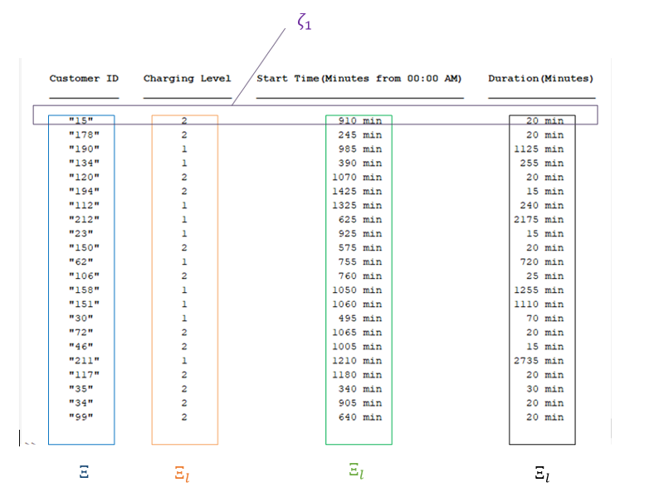

Figure 5. Annotated ev scenario

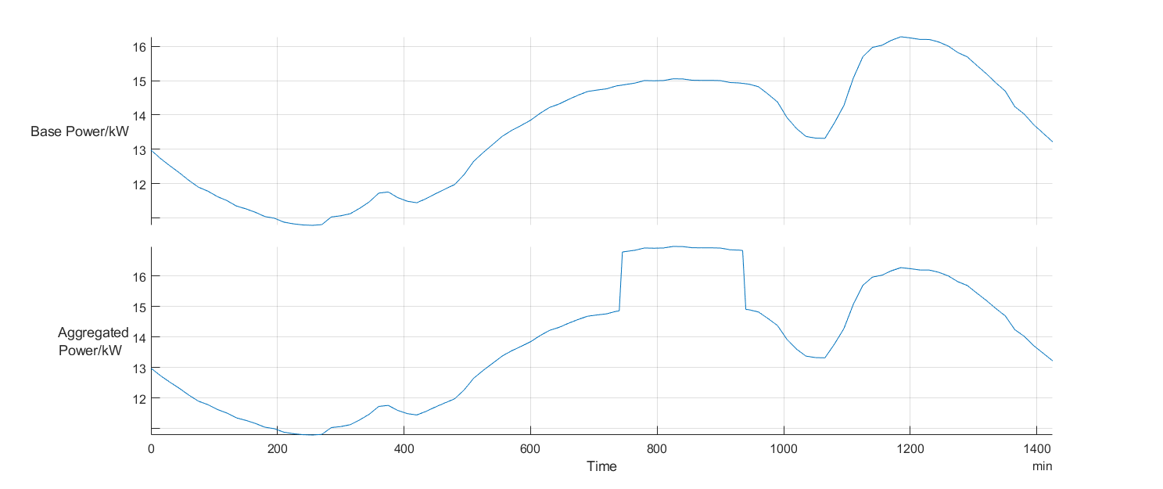

Figure 6. SAMPLE BASE AND AGGREGATED LOAD PROFILE

#### Analysis Layer

EV demand results will be aggregated to the base load created to obtain the net demand profile for the system under various scenarios of penetration and charging levels. Two types of impact assessments will be done; steady state and transient. Power flow analyses will be conducted using the generated demand and infrastructure data to determine the adequacy of the electrical supply infrastructure in the steady state. For each generated scenario, multiple power flow solutions will be obtained at 1 hour increments during the day to assess the impacts on the feeder for a variable load throughout a selected day. Time domain simulations will then be conducted to assess the transient impacts of the network for charging under these scenarios.

The specific impacts to be assessed in this study includes voltage sag, voltage unbalance, overloading and harmonics. They are explored in more detail below.

1. Voltage Sag - The IEEE 1159 standard describes this as a 10-90% decrease from nominal voltage for the duration of 8ms to 1 minute. If a significant number of EVs charge simultaneously (uncoordinated charging), this can lead to an increase in power demand from the substation. Until corrective action to increase power transported across the distribution network to meet the power requirements of these EVs occur, lower than nominal voltages (voltage sags) may temporarily exist for some customers particularly the last mile customers. Voltage sags generally affect the operation of customer rotating equipment, controllers and flickering of lighting. In extreme cases for sensitive equipment, this can lead to malfunction, shutdown and possible damage.
2. Voltage Unbalance - The IEEE standard 141 defines this as the maximum deviation from the average phase voltage, referred to the average of the phase voltage. as prescribes that phase-voltage unbalances should be limited to be below 2%. The uneven distribution of single-phase charging and will lead to unequal voltage drops in the different phases of the distribution grid. The IEEE voltage unbalance limit of 2% can be exceeded in extreme cases. From grid side – increased network losses, heating and subsequently reduced operational limits of three phase cables and transformers. From consumer side – heating, vibrations and derating of three phase machinery.
3. Overload - A thermal overload occurs when an asset transmits more power than its design rating. The additional power consumption due to the charging of EVs leads to thermal overload of assets such as transformers, cables and leads to operation of assets above its design rating. Operation of equipment with overloads accelerate aging of the insulations systems and reduce the lifetime of the assets.
4. Harmonics – This refers to distortions in the voltage and current waveforms. The IEEE 519 standard recommends a total harmonic distortion limit of 8% for low voltage systems (<1 kV). EV charger characteristics adds current and voltage harmonics, distort the waveforms, causing stress in the electrical equipment. Overheating and electric stresses in power system equipment which may lead to subsequent damage.

# References

Matteo Muratori. Impact of uncoordinated plug-in electric vehicle charging

on residential power demand - supplementary data. National Renewable

Energy Laboratory, 10:7799, 2017

Matteo Muratori, Vincenzo Marano, Ramteen Sioshansi, and Giorgio Riz-

zoni. Energy consumption of residential hvac systems: A simple physically-

based model. In 2012 IEEE Power and Energy Society General Meeting,

pages 1–8, 2012

Matteo Muratori, Matthew C. Roberts, Ramteen Sioshansi, Vincenzo

Marano, and Giorgio Rizzoni. A highly resolved modeling technique to

simulate residential power demand. Applied Energy, 107:465–473, 2013a

Matteo Muratori, Michael J. Moran, Emmanuele Serra, and Giorgio Rizzoni.

Highly-resolved modeling of personal transportation energy consumption in

the united states. Energy, 58:168–177, 2013b

U.S. Energy Information Administration. 2009 RECS Survey Data, 2009

Fuel Institute. Ev consumer behaviour report. Technical report, Fuel Insti-

tute, 2021.

# Appendix I

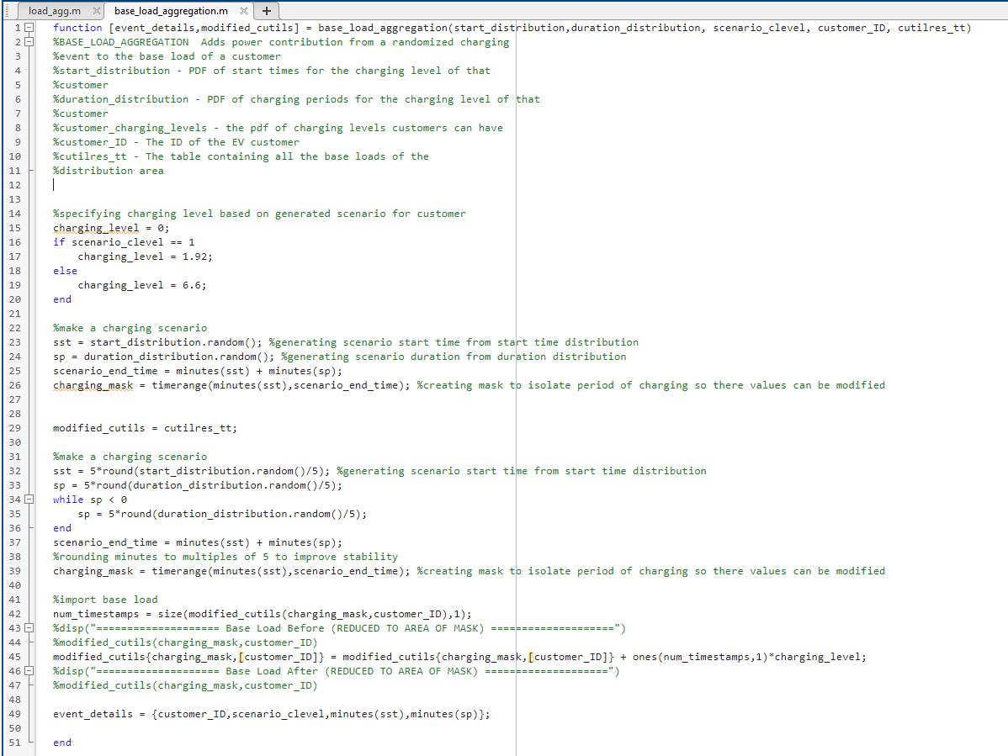

Figure 7 BASE LOAD AGGREGATION HELPER FUNCTION

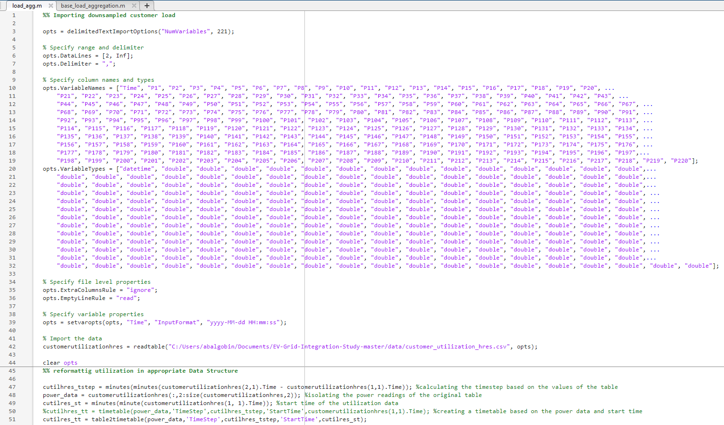

Figure 8 ev scenario generation snippet-1

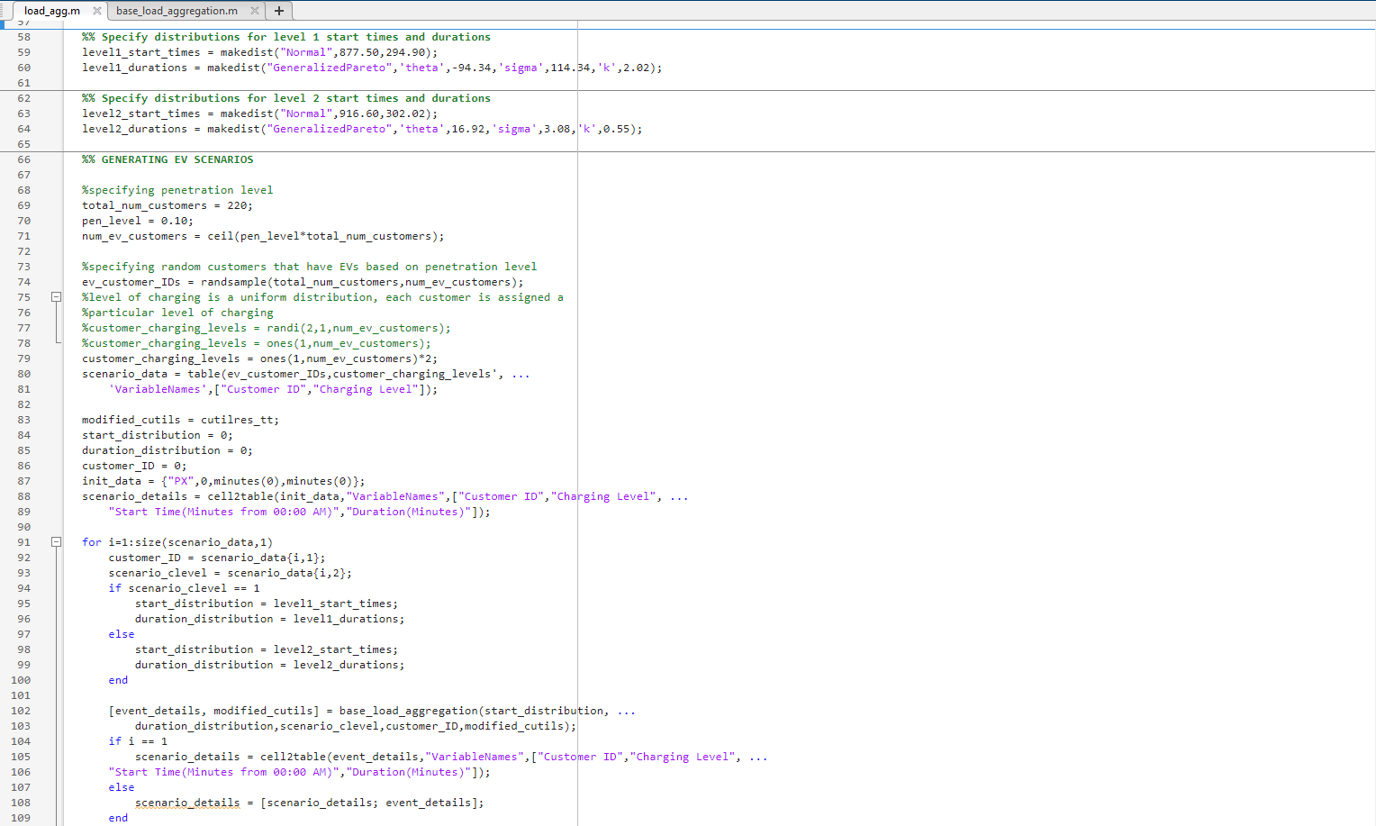

Figure 9 ev scenario generation snippet-2

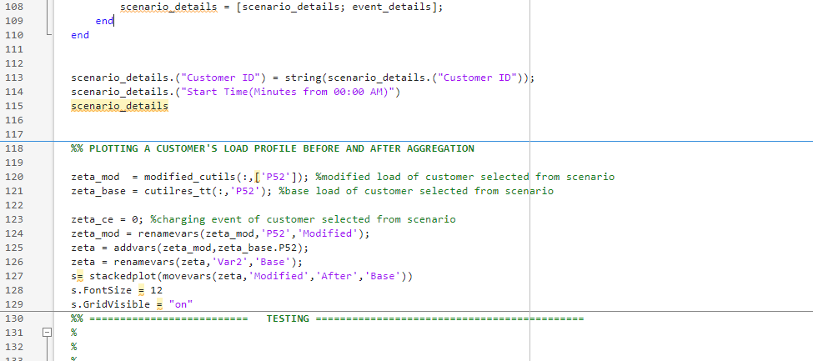

Figure 10 ev scenario generation snippet-3

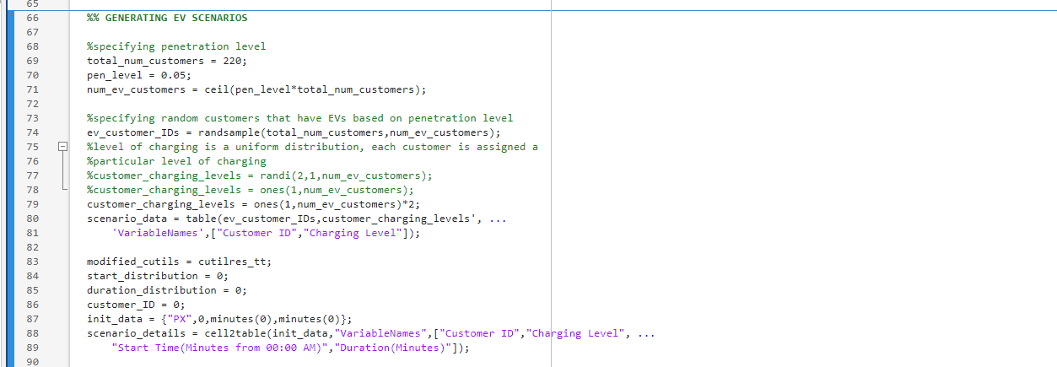

Figure 11. EV GENERATION SCNEARIO SHOWING PENETRATION LEVEL CHANGED FROM 10% TO 5%

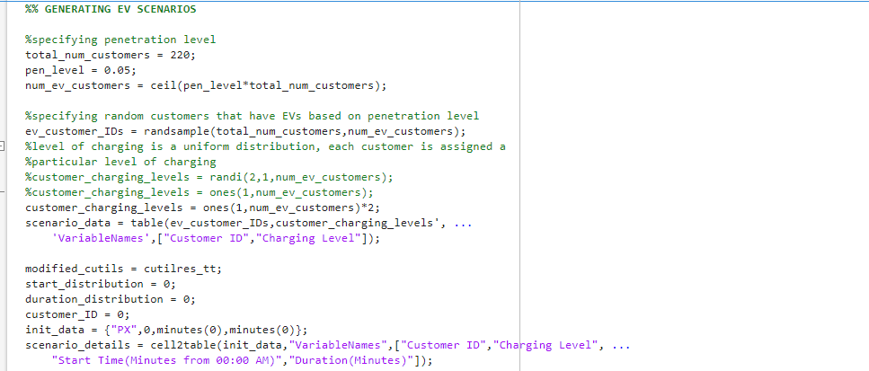

Figure 12 EV GENERATION SCNEARIO SHOWING PENETRATION LEVEL CHANGED FROM 5% TO 15%

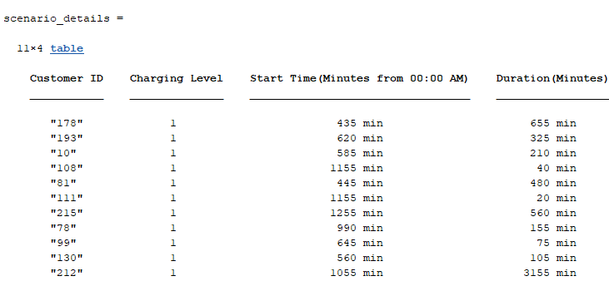

Figure 13 EV SCEnario for only level 1 charging at 5% penetration

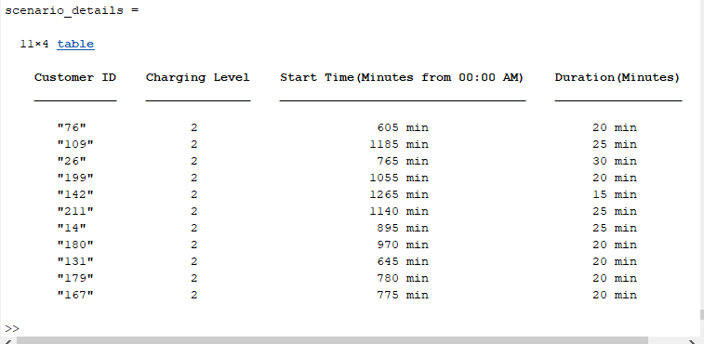

Figure 14 EV SCENARIO FOR ONLY LEVEL 2 CHARGING AT 5% PENETRATION

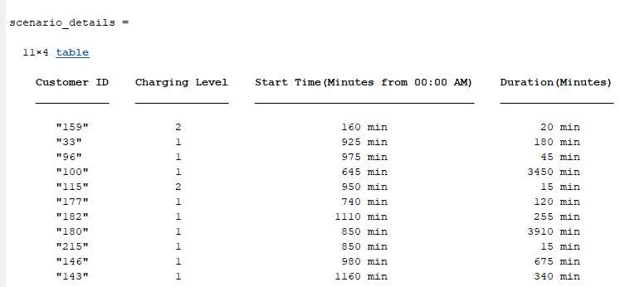

Figure 15 EV SCENARIO FOR LEVEL 1 & 2 CHARGING AT 5% PENETRATION

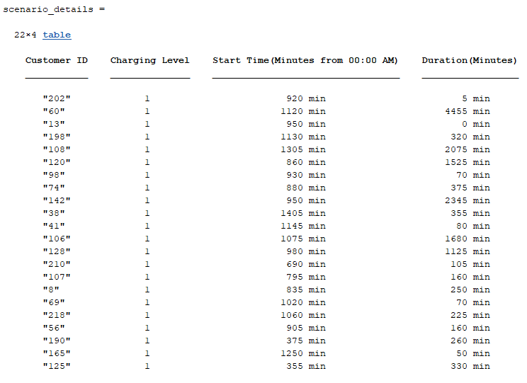

Figure 16 EV SCENARIO FOR ONLY LEVEL 1 CHARGING AT 10% PENETRATION

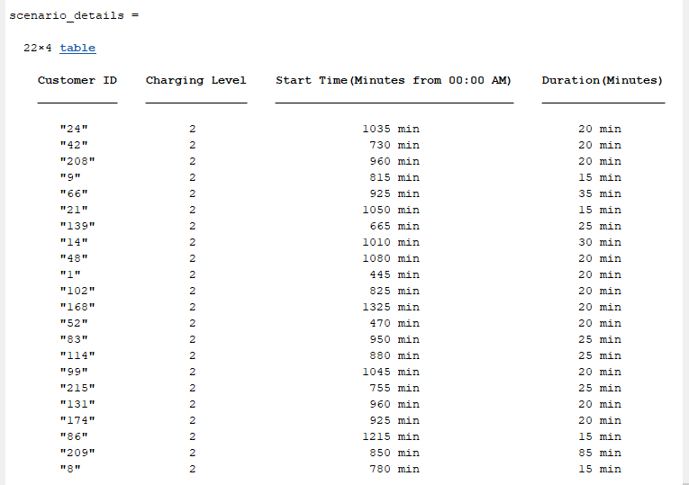

Figure 17 EV SCENARIO FOR ONLY LEVEL 2 CHARGING AT 10% PENETRATION

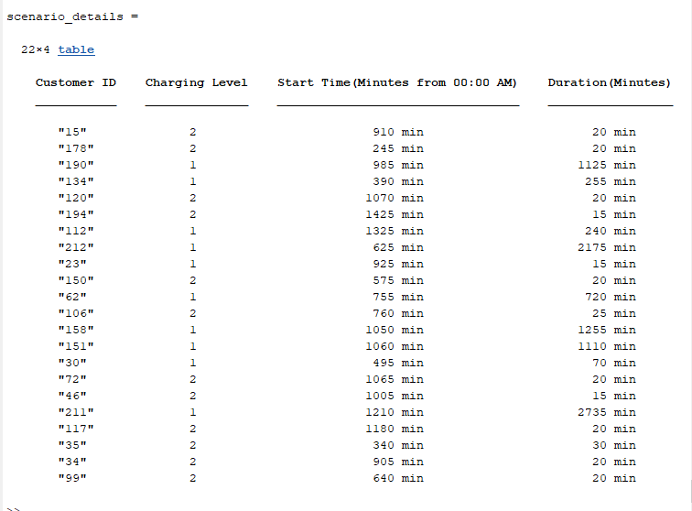

Figure 18 EV SCENARIO FOR ONLY LEVEL 1 & 2 CHARGING AT 10% PENETRATION

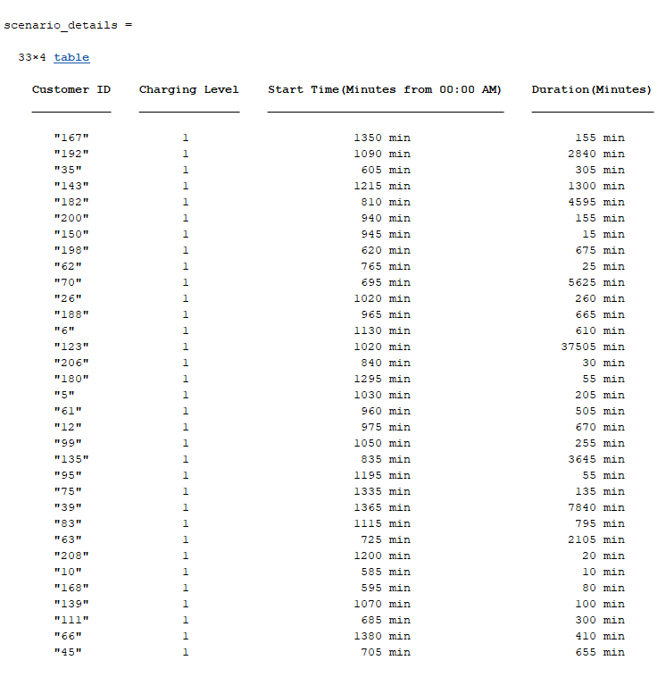

Figure 19 EV SCENARIO FOR ONLY LEVEL 1 CHARGING AT 15% PENETRATION

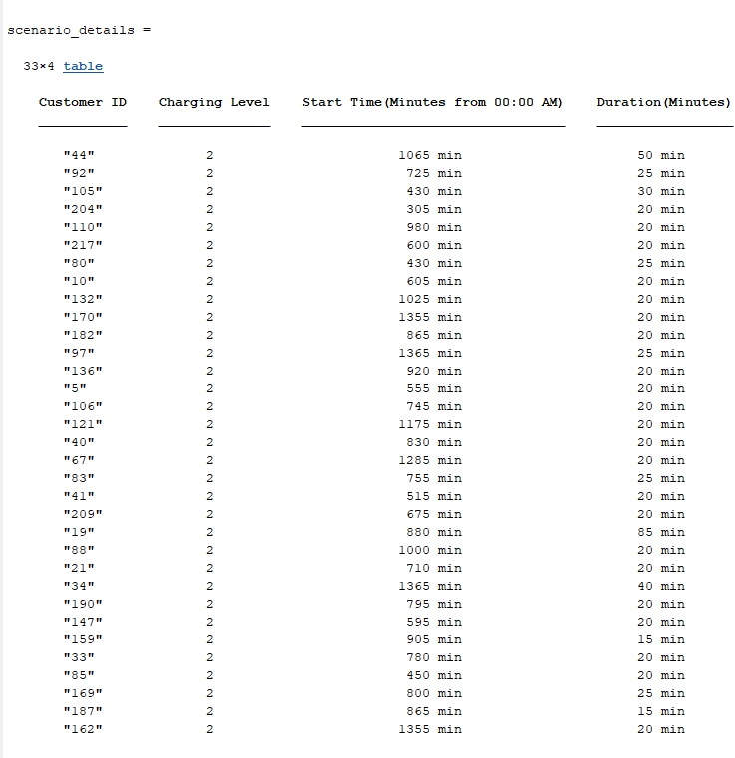

Figure 20 EV SCENARIO FOR ONLY LEVEL 2 CHARGING AT 15% PENETRATION

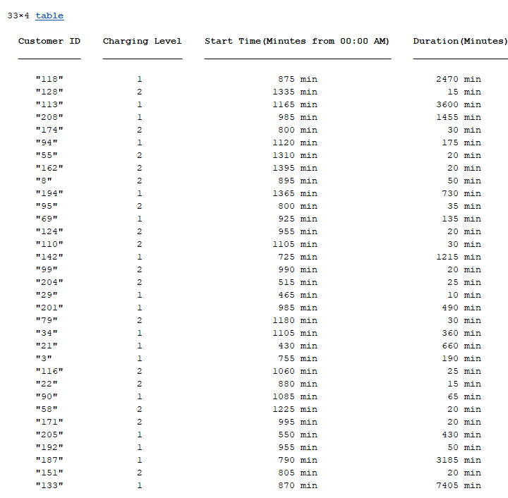

Figure 21 EV SCENARIO FOR LEVEL 1 & 2 CHARGING AT 15% PENETRATION

1. means it is a column of xs